Internet Governance Forum (IGF) Program Shaping - 2018
20 April 2018

Context:

Based on the community inputs during the Internet Governance Forum (IGF) 2017 stocktaking processes, the Commission on Science and Technology for Development (CSTD) Working Group on IGF Improvements, the IGF Retreat organized by the United Nations Department of Economic and Social Affairs (UNDESA), as well as the first 2018 IGF Open Consultations, many community members and Multistakeholder Advisory Group (MAG) members expressed their preference for having more concrete, concise, focused and cohesive discussions during the IGF annual meeting, trying to avoid duplicate sessions and reducing the number of parallel sessions.

During the first 2018 IGF MAG meeting, those community inputs were taken into account to provide a thematic approach that is more likely to deliver the requested results. Therefore, the following fourstep proposal attempts to incorporate the main consensus-based views expressed during the MAG meeting as a result of the aforementioned stock taking exercises
It is imperative that the MAG engage with all Intersessional activities (Best Practice Forums (BPFs), Dynamic Coalitions (DCs), Connecting and Enabling the Next Billion(s) (CENB)) and the National, Regional, Sub-regional and Youth IGF Initiatives (NRIs), as well as the IGF community to help advance and maximize these enhancements.
In order to advance the program shaping for IGF 2018, given the compressed time, we had to move expeditiously. Immediate actions are needed after the Call for Issues completes, in order to release the Call for Workshops in a timely manner.

The MAG supported an Ad-hoc group to help advance the process and the focus was:
- Agree next steps once Call for Issues is closed
- Discuss and prepare for full MAG review:
  - Integration/implications for Call for Workshops
  - MAG’s role in shaping the program - new responsibilities? Changes?
  - Desired changes to the Workshop evaluation process

Four Step Approach:

A four-step approach was supported (covered in more detail below):

- Baskets + Call for issues
- Call for Workshop Proposal
- MAG Evaluation Process
- Program Shaping

1) Baskets + Call for issues

The ad-hoc group recognizes the importance of understanding community interests in preparing the IGF, and

emphasized the importance of understanding interests by stakeholder group and region. There was agreement that a grid should be developed to support this analysis. The IGF program would then reflect that interest and work to equitably address the interests of all stakeholders (this is not a numerical process but a qualitative one).

The grid would also help to visualize the presence of cross-cutting themes and preference of the community by stakeholder group and region.
Following the ‘Call for Issues’ the group agreed to standardize on terminology, so ‘baskets’ would become ‘themes’, and ‘issues’ would become ‘sub-themes’.

2) Call for Workshop Proposals

How will the themes and sub-themes identified through the Call for Issues shape the Call for Workshop (WS) Proposals?

The group proposes:

- Evaluating the input received from the ‘Call for Issues’ to determine what/if any Themes and Sub-themes should be preferred in the Call for WS. Any preference would be based on interest shown from the community, the relationship to Internet Governance as well as the substantive nature of the issues proposed. An ‘Others’ category would still be included in the Call for WS.

- Reviewing ‘Call for Issue’ Submissions to ensure all stakeholders interests are reflected in the Call for WS and ultimately in the IGF program. The overall level of interest in themes/sub-themes should be evaluated on the level of interest within each stakeholder (SH) group, and then all SH groups treated equitably in the program. This is a qualitative exercise and not a quantitative one.

- That Issues (from the ‘Call for Issues’ exercise) be consolidated/grouped into Sub-themes, and Themes and Sub-themes would serve as the basis for the Call for WS.

- That the purpose of the tags used the last two years has been supplanted by the Call for Issues, and recommends that we move to incorporate the Themes/Sub-themes in the Call for WS.
- A traditional call for workshops will be launched, largely following the current established methodology and criteria, asking people to:
- indicate which set of Sub-themes their proposal was supporting (following Tags process from previous years);

- NEW: clearly indicate the (policy) question their WS will be addressing (per the CSTD WG on IGF Improvements recommendations), note: this could replace the previous years “Relevance” field;

f. The Call for Workshop Proposals will also:

- Strongly advise that, to help ensure balanced perspectives, workshop proposals submitted by two or more different stakeholder groups (e.g. technical community, government, civil society, private sector) from more than one geographical region, will be privileged.

- Remind submitters that creative approaches to session formats, as an alternative to the traditional panel format, are strongly encouraged.

- Encourage diversity related to gender, youth, geographical and stakeholder groups among speakers/participants.

- Invite submitters to build on previous workshops/work done (and indicate such in WS submission) in order to make progress on the issues, and avoid recurrent discussions.

- Ask Submitters to provide previous background documents or resources to better inform the proposal evaluation process and indicate concretely how the WS will advance the issue.

- Instruct submitters to allow a significant portion of the session time (50%??) for discussion and audience participation, for example by limiting lengths of interventions and having a manageable number of speakers.

- Remind submitters of the responsibility to provide their session report within 2 weeks of the Annual Meeting.

- Remind submitters the submission of a report from previous workshops is mandatory in order for their proposal to be considered.

3) MAG Evaluation Process

- Following the current evaluation methodology, MAG members are randomly grouped according to diversity criteria of gender, region and stakeholder representation.
- To enable a thematic approach, each group of reviewers will then be assigned Sub-themes. This allows MAG reviewers to have a full understanding of the workshops proposed by sub-theme, thus better able to assess the quality of the proposal, identify similar proposals and/or same speakers. Importantly, this should help the MAG build a more cohesive program and one that focuses on significantly advancing issues. The MAG will also take care to review cross-cutting sub-themes to ensure balance and cohesiveness, and avoid redundancy.
- Each sub-theme should also take into consideration the relevant thematic work by Intersessional (BPFs, DCs, CENB) and NRI activities in order to more fully cover the sub-themes, while respecting the bottom-up decision processes of each of these activities. Full integration may not be possible in all cases, especially given the compressed timetable of these process changes.

- MAG members will be able to change group if they are not familiar with the topic, subject to usual reviews to ensure impartiality, etc.
- Each group should be able to signal a recommendation to change any WS proposal from one sub-theme or from one theme to another, depending on the issues addressed. Similarly, sub-themes which are clearly cross-cutting across themes should be flagged and thoughtfully reviewed.
Further, the MAG is expected to:

- Engage with all Intersessional activities and the NRI co-facilitators to help advance these improvements (Note: proposals for doing so are needed and must recognize their different processes)

- Communicate process changes and rationale to the community – at time of Call for WS launch if not possible before

- Clarify any new expectations in the evaluation process (see above);

- Develop a Frequently asked Questions section;

- Undertake a stocktaking of the process by the 2018 MAG after the WS Proposal process closes AND after the IGF meeting, as an input to the 2019 MAG.

4) Program Shaping

The MAG will review the workshop proposals preliminarily approved and will create specific tracks broadly in line with themes proposed in the workshop proposal process, following community interest and ensuring an equitable and balanced program across all stakeholder groups. The track may be structured in such a way that one WS feeds into another or builds on another (an extended discussion, if you will). The MAG may decide that merging or blending WS proposals will better advance the sub-themes and if so, will work with WS submitters to complete these mergers.
This approach emphasizes quality and issue advancement. Each track should include main sessions, approved workshops and/or additional activities selected by the MAG, ensuring space is left open for thematically relevant open forums, intersessional results (BPFs, DCs, CENB) and NRIs.
Interactive sessions, focused on responding to concrete policy questions, will be privileged.
IGF messages (building on the Geneva messages from IGF 2017) will be produced by the workshop organizers and rapporteurs for each Workshop, under a process managed by the IGF Secretariat. The workshop organizers are encouraged to get input on these messages from workshop participants. Note: these messages are in addition to the full workshop report due as a mandatory output.
IGF Messages will also be produced for all Main sessions (tracks). This message development would be the responsibility of the session rapporteurs under the control of the IGF Secretariat with consultations with the host country, MAG Chair, and main session organizers.
As a consequence of having less parallel sessions, less workshops will be approved, but community engagement will have increased given these process and program changes.

A Visual Guide

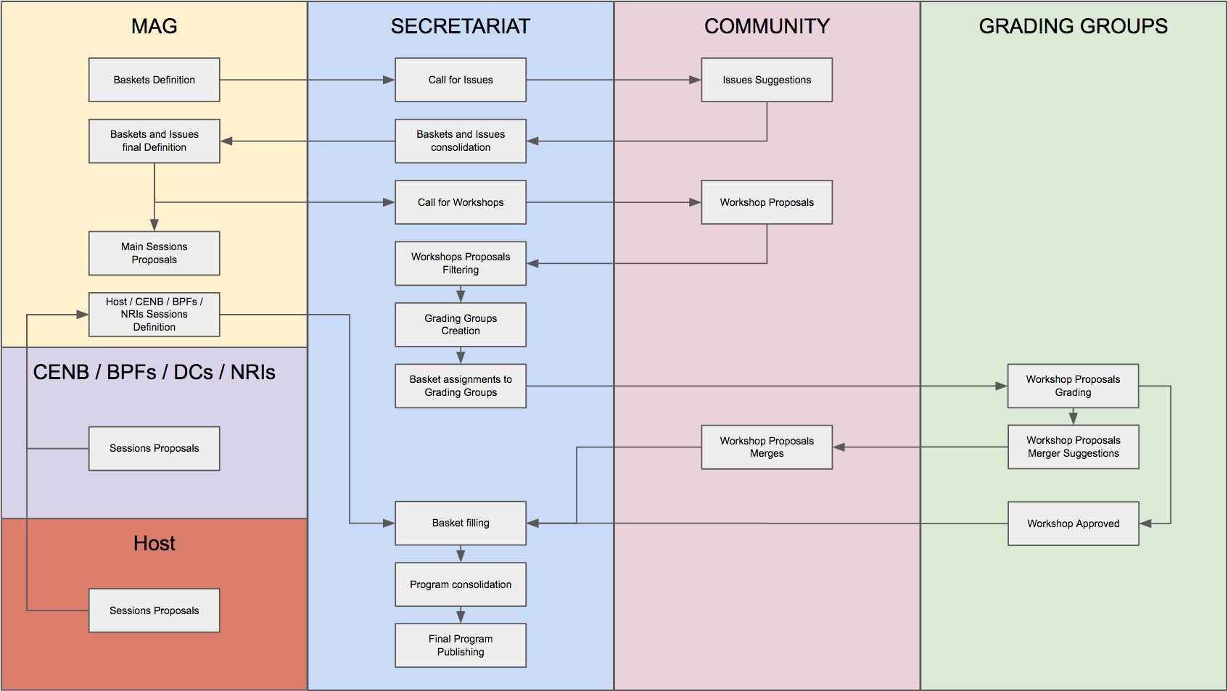

Proposed Workshop Process Timeline

26 MARCH-13 APRIL 2018 | Call for issues
16 - 20 APRIL 2018 | Secretariat Review and Analysis of Issues
30 APRIL-27 MAY 2018 (4w) | Call for Workshop proposals published
28 MAY-30 MAY (3d) | Secretariat run through
31 MAY-17 JUNE 2018 (2w) | MAG Evaluations
18-29 JUNE 2018 (11d) | Secretariat Analysis of Evaluations, Possible Thematic Track Formation
2-8 JULY 2018 (1w) | MAG Review of Results
11-13 JULY 2018 (3d) | 2nd OC/MAG F2F meeting

Next Steps:

- Secretariat will prepare a spreadsheet with the inputs received from the call for issues once the deadline is closed, including the regional and stakeholder proponents per issue.

- Assessment of the call for issues grid: (i) identify issues that can be moved for other categories; (ii) identify cross cutting issues and possible merge of themes/sub-themes

- Secretariat to draft a Call for Workshops for review by the MAG - Due no later than COB April 23rd

- MAG to review Call for Workshops on MAG call scheduled for April 25, 2018

URGENT: Open Questions for MAG Working Group on Workshop Evaluations

- For the MAG’s evaluation process (and therefore the Call for Workshops), we need to improve how we classify workshops by diversity criteria. It is not useful to classify it by one region or one SH group based on who wrote up the submission, especially when the proposals are multi-stakeholder and geographically diverse. And, it is being gamed.
- How can this be improved and what do we need to know/do for the Call for Workshops.

This will be reviewed on the MAG call scheduled for April 25th in order to support the Call for Workshop Proposals to be launched on April 30th, 2018.

For reference: Ad-hoc group members:

Raquel Gatto, Israel Rosas, Miguel Ignacio Estrada, Alejandra Erramuspe, Jennifer Chung, Liesyl Franz, Mary Uduma, Jutta Croll, Rudolf Gridl, Arnold van Rhijn, Ben Wallis, Timea Suto, June Parris
Lynn St Amour, Thomas Schneider, Jorge Cancio, Livia Walpen, Rasha Abdulla, Zeina Bou Harb, Pablo Bella, Chengetai Masango, Eleonora Mazzucchi, Anja Gengo, Luis Bobo Garcia, Lynn St.Amour

<end>

