QUESTION ONE
To date, the CSCG has basically acted as a conduit for nominations for civil society to outside bodies.
What other functions, if any, should the co-ordination group exercise?

The majority of comments either favoured keeping the functions to nominations only, or taking a “wait and see”
attitude to how it might evolve.

Other suggestions included developing position papers and working on policy advocacy issues. But the strong
consensus was towards working on nominations and evolving slowly if other functions are needed.
Do you think the group needs a written constitution or charter, and why or why not?
Yes | 18 | 60.00%
No | 11 | 36.67%
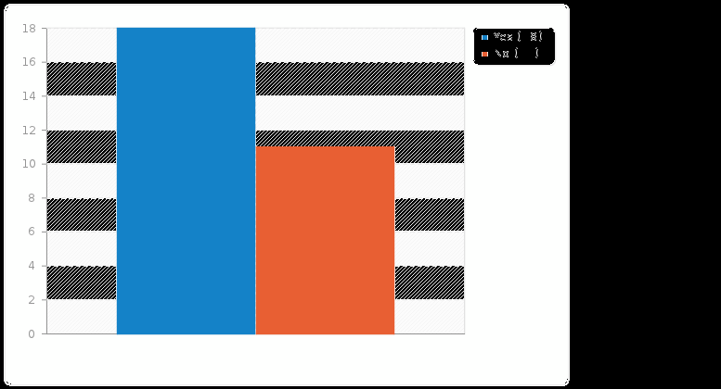

Those who commented here overwhelmingly thought that some sort of charter was necessary (even if a minimal document) to clarify scope, responsibilities and accountability.

Field summary for 3
Civil Society Co-ordination Group membership should be open to:
Answer | Count | Percentage
Representatives of civil society global networks only (A1) | 8 | 26.67%
Representatives of civil society global networks and representatives of civil society organisations (A2) | 2 | 6.67%
Representatives of CS global networks, CS organisations, and individuals actively involved in civil society global networks (A3) | 16 | 53.33%
No answer | 4 | 13.33%
Not completed or Not displayed | 0 | 0.00%
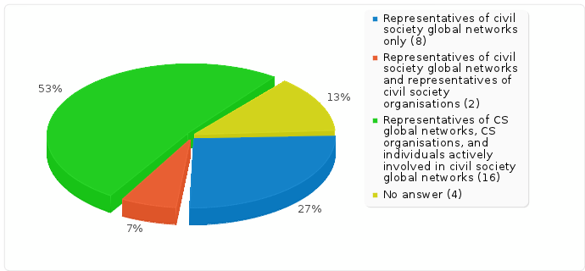

Field summary for 3a
Which of the following should the committee adopt (and optionally, why)?
Two-year term limits, to allow for rotation | 19 | 63.33%
Appointment of 5 new members, joining the existing 5 | 12 | 40.00%
Standing membership for core groups, who would be exempted from rotation | 7 | 23.33%
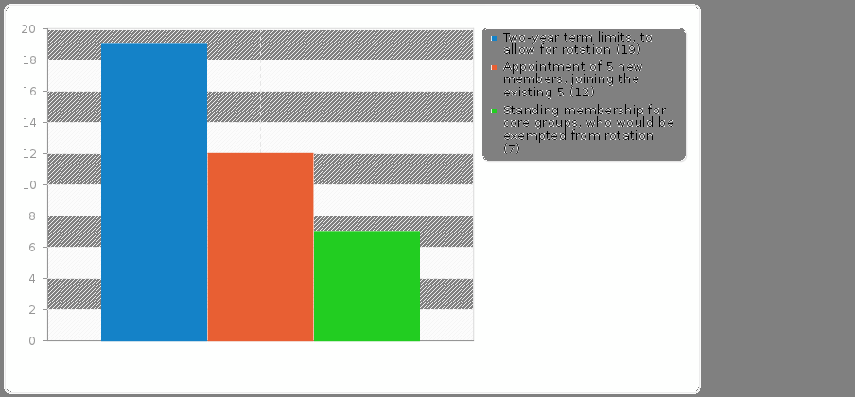

It should be noted that the only comments received on this particular question pointed out that should core groups be rotated out and no longer involved the concept would be meaningless, and that particularly in initial stages their support and involvement was necessary

Field summary for 4
How should the group be chaired?
Answer | Count | Percentage
Group will choose a non-voting chair themselves after a call for volunteers (A1) | 17 | 56.67%
The group will vote one of their own number as a chair who has only a casting vote (A2) | 7 | 23.33%
Other | 4 | 13.33%
No answer | 2 | 6.67%
Not completed or Not displayed | 0 | 0.00%
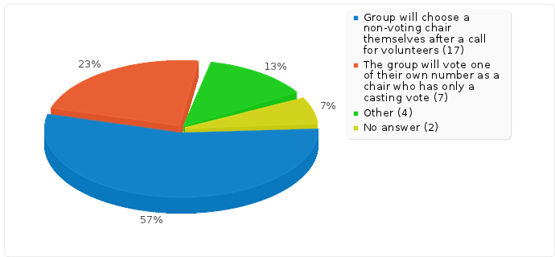

Criteria Weighting
Globally representative)  6.5 | Non-commercial and public interest oriented  8.6 | Broad range of civil society interests covered  7.5 | the internal governance of the organisation is adequately transparent and accountable to its member  8.7 | a substantial current involvement in and knowledge of internet governance issues  8.4 | demonstrable involvement in interests/ issues related to marginalised groups  7 | able to work collegiately with other civil society stakeholders  8.4 | no substantial overlap in membership with current members  4.7

Other criteria supported in additional comments included geographical and gender balance.

Other general comments

Do you have any other suggestions as to how the CSCG should function?
Don't become another site for contestation. Stick to logistics and democratic process.
Tread softly and deliberately.
Be lightweight to act, allow mistakes to make be tolerant with each other.
As a simple coordinating group for those few occasions where a relatively coordinated response from a majority of civil society groups is required.
Since the composition of the coordination group will never be perfect, it needs to operate in such a way that it is not particularly important for groups and networks to be represented on the coordination group. For this reason, it is not good for the coordination group to decide nominations. When the coordination group organizes a randomly-selected-NomCom process, it is much less important who is represented on the coordination group, solving that problem.
Publish simple procedures.
learning from nomcom experience like in IETF and ICANN. ICANN nomcom yearly update its operating rules and have a monthly report on its activities
Most of these are volunteers and need t be encouraged and supported. Less suspicion is necessary until otherwise proven wrong.
I have reservations about the idea of having the committee at all although i recognise the validity of the something better than nothing argument. It seems highly important that now particularly everything should work towards a unified civil society response
as a collection point and source of communications out to its membership on events and discussions of interest to the broader community
Find a way of eliciting greater participation by many of the existing dedicated member's who are the silent "informed" majority.

