Let’s assess and improve the Internet:

Help UNESCO develop the tools

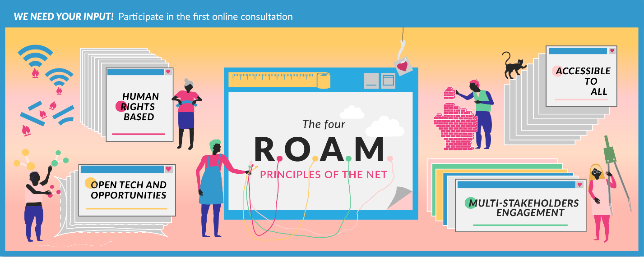

We need your input! Help UNESCO develop Internet Universality Indicators by participating in the Phase 1 online consultation.

UNESCO is developing an indicator framework to help governments and other stakeholders assess the extent to which Internet Universality principles govern their national Internet environments – and help them implement those principles into the future. The indicator framework is based on the principles of UNESCO’s Internet Universality R.O.A.M framework. There will be five categories of indicators, concerned with:

Rights (R)
Openness (O)
Accessibility (A)
Multistakeholder Participation (M) and
Cross-Cutting Issues (X)

The indicators project draws on UNESCO’s experience with the Media Development Indicators (MDIs) which were adopted as part of the Organization’s International Programme for the Development of Communication (IPDC) in 2008. The MDIs have enabled a variety of stakeholders to undertake comprehensive assessments of national media environments using quantitative and qualitative indicators, and producing helpful recommendations for improvement.

The indicators resulting from this new project will not address every aspect of the Internet, but will focus on the four R-O-A-M principles and cross-cutting issues – and include the impact of the Internet on gender issues and on children and young people.

The outcome will include both quantitative and qualitative indicators, enabling a comprehensive view to be taken of national developments in any given UNESCO Member State, as well as recognize different experiences and different characteristics between different countries.

The indicators will be developed through an extensive programme of desk research and consultation.
Internet Universality
In 2015, UNESCO’s General Conference adopted the concept of “Internet Universality” to highlight features of the internet which UNESCO believes are fundamental to fulfilling its potential for sustainable development.
The concept was developed by UNESCO through an extensive programme of research, analysis and consultation with Member States and the internet stakeholder community.
It recognizes that the internet is much more than infrastructure and applications. It is a network of economic and social interactions and relationships, which has great potential to enable human rights, empower individuals and communities, and facilitate sustainable development.
Understanding the internet in this way helps to draw together different facets of internet development, concerned with technology and public policy, human rights and development.
Internet Universality: A Means Towards Building Knowledge Societies and the Post-2015 Sustainable Development Agenda, UNESCO Discussion Paper, 2013:
“Internet Universality” as a concept captures what is important in the light of the growing pervasiveness of the Internet in human affairs. It highlights the behavioral norms and values underpinning this trend. It points to the need to strengthen these so as to have an Internet that helps realize the highest aspirations of humanity, which is ubiquitous and serves everyone, and which reflects general participation in its development and governance.

The online consultation
This questionnaire aims to gather your views on what you think should be included in the indicator framework. On this basis, draft indicators will be produced. Towards the end of 2017, we will be publishing these drafts, and we will then ask for your views about those options in a second round of consultation.
Your insight is requested at this stage for the initial phase of consultation. The questionnaire takes about 20 minutes. Contributions can be made in any of the six UN official languages (Arabic, Chinese, English, French, Russian, Spanish). We intend to make contributions available online (in their original language). You can also decide to not have your contribution published if you wish.

First online consultation questionnaire: Deadline 31 October 2017.
More information and the questionnaire online: https://en.unesco.org/internetuniversality

If you prefer to submit your contribution by email or by mail, please fill this form below and address your response to UNESCO (internetstudy@unesco.com).
Personal information
Name

Organization

Only information concerning name and organization will be included when contributions are published online. Please state if you do not wish your contribution to be published:
Email address

Country/region

Gender

How would you define the stakeholder community or communities to which you belong? | Government  Intergovernmental organization  Internet technical and professional community  Private sector  Civil society  Academic  Journalism/media  Individual capacity  Other (please specify):

Questions
What are your priorities for issues that should be addressed through the Internet Universality framework in each of these five categories?
3

Rights
Openness
Accessibility
Multistakeholder participation
Cross-cutting indicators

Are there are any existing indicators with which you are familiar that you think it would be useful to include in the ROAM indicators framework?
2

Rights

Openness

Accessibility

Multistakeholder participation

Cross-cutting indicators

What do you think are the most important gaps in data/evidence required for monitoring Internet Universality and the ROAM principles? What approaches do you think could help to address these in your country, region or area of work?
3

Rights

Openness

Accessibility

Multistakeholder participation

Cross-cutting indicators

What experience or views do you have of indicators relating to the Internet which are concerned with gender and with children and young people?
4
Please mention any indicators you consider useful here and provide references.

How do you think you might use the indicator framework for Internet Universality once it has been developed?
5

6
How do you think that other stakeholders might use the framework?

Please add any other comments that you think will be helpful to UNESCO in developing the indicators framework.
7

Thank you for participation! Questions concerning this report, the project and submissions should be addressed to (both) Xianhong Hu on behalf of UNESCO (x.hu@unesco.org) and David Souter on behalf of the UNESCO commissioned consortium (david.souter@runbox.com).

More information and online participation: https://en.unesco.org/internetuniversality

