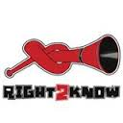 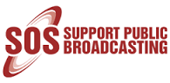 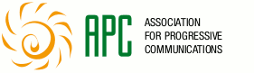 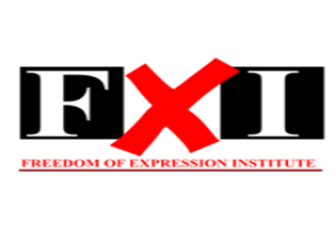 27 May 2015
On Thursday, 28 May, the Film and Publications Board (FPB) will hold a public hearing on their latest draft regulations. The Board is attempting to give itself sweeping powers to police what we see, hear and say online. The Right2Know Campaign and allied organisations opposed to internet censorship – the SOS Coalition, Freedom of Expression Institute and Association for Progressive Communications – invite the media to a preparatory meeting prior to the FPB public hearing.
The meeting will take place at CIVICUS in Newtown (28 May from 13h30 to 16h15). Light refreshments will be served. Participants will then move to the FPB hearing which takes place from 17h00-19h00 at the Turbine Hall (The Glass House), 65 Ntemi Piliso Street.
The FPB’s Draft Online Regulations Policy would open the way for undue censorship of the internet under the guise of protecting the public from harmful content. The policy will have the effect of curtailing our constitutional right to freely receive and impart information and ideas. We believe the key proposals in Draft Policy are out of touch with the realities of how we use the Internet, and possibly infringe on foundational constitutional provisions.

It is important that the FPB hearing is packed with critical voices! We need to show in the strongest terms just how seriously we take attempts to censor the internet.
We urge all who realise the gravity of the threat of internet censorship to attend our pre-hearing meeting where we will dissect and debate the issues, and attempt to chart a clear and united way forward.
#HandsOffOurInternet
Date: 28 May 2015 Time: 13:30 – 16:15
Venue: Civicus House, Indaba Room, 24 Gwigwi Mrwebi St, Newtown, JHB & afterward moving to the FPB public hearings at the Turbine Hall (The Glass House), 65 Ntemi Piliso Street.

For comments contact:
Micah Reddy on 083 297 3444 or micah.reddy@oxon.org

